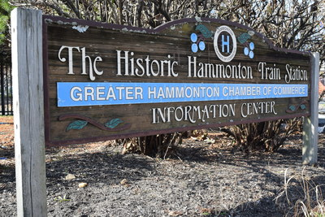
The town of Hammonton By Gianna Morganti

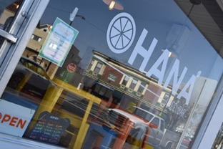
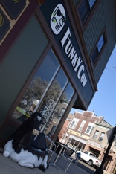
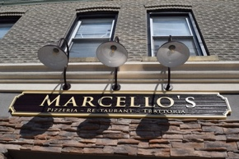
The town of Hammonton is a one of a kind town, it is very unique. Hammonton to me is a place where everyone knows each other and shares so many great and fun things. There are so many great family owned restaurants, gyms, clothing stores, candy shops, etc. It is so warming and calming because I can just safety walk or ride my bike around town and shop. When walking around I feel safe it just makes me happy because when you pass people or walk by them everyone always says hi or just simply smiles at me. A few places I love to stop in to either shop or eat are “Ohana”,
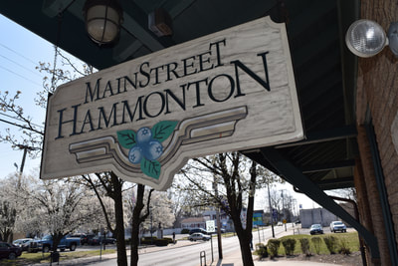
“Marcellos”, “Saddys” “Sweet Creations”, and The Nail Salon. Another great
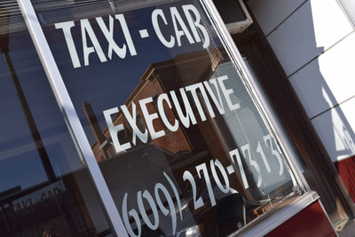
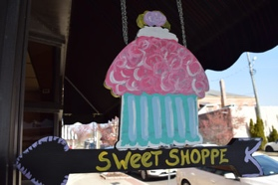
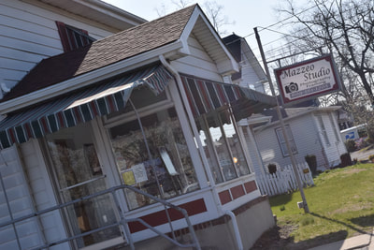
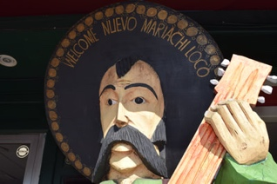
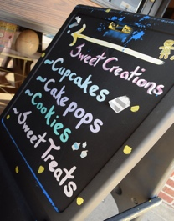
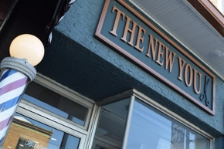
business that I love to go to for special occasions is called “Our expressions”. These are my favorite businesses because the food and clothing are not only the best but the service is great. Everyone is so nice and because Hammonton is a small town they know me when I go. Also, they are so thankful for my business, unlike other places I have been outside of Hammonton where they are rude and just want there money, these Hammonton businesses do not do that.
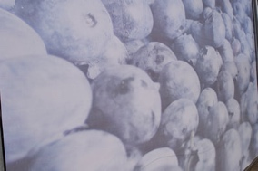
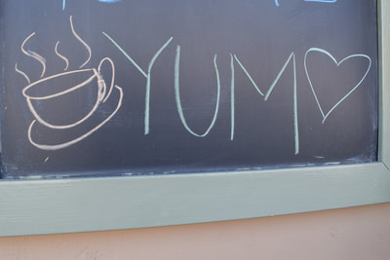
A very special quality that Hammonton has that I love so very much is BLUEBERRIES! Hammonton is the “Blueberry Capital of the World” Many families have blueberry farms and every year we have this fun event to show off all the blueberry company’s. This event celebrates Hammonton as being the “blueberry Capital of the World”. I love blueberries and it is the best time of the world. Its hectic for the blueberry farming families but its great because blueberries are great. The blueberry Festival is a big event in Hammonton but there is also another event that goes on every July called the Our lady of Mount Carmel Festival/Carnival. Every year I attend this wonderful event. So many people come to hang out ride the rides play games and of course eat the outstanding food. The food is made by volunteers from Hammonton. The carnival brings so many people together, people you havemt seen in a long time. It is such a great event and a once a year thing with great food that you cant help not t stop by. I myself see so many friends and family there! All the events held in Hammonton are truly great events and I have such a great time while feeling safe!
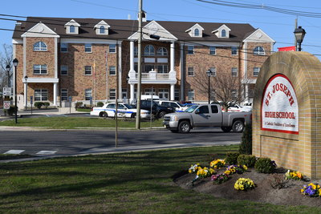
I never have lived in Hammonton but Hammonton feels like my home. I attend school in Hammonton not the Public school but St. Joseph High School in Hammonton which is right across the street from Town Hall. I do have many friends that attend Hammonton Public School but St. Joe where I am currently a senior at I have many more friends. St. Joe which is a small Catholic school. I feel like St. Joe is just a big family, where everyone knows each other and that’s one thing I love about it. I have made so many great memories and great friendships. Having St. Joe located in Hammonton makes it such a great unique place. With Hammonton being such a small friendly town many people like myself and many classes like mine are friends with many of Hammonton High School.
There is something about the town of Hammonton its just so great, I wish I lived here so that I could experience this way more often. Its such a great place and I have made so many great memories. I am so thankful that my parents gave me the opportunity to attend St. Joe is Hammonton because it has allowed me to experience this great town of Hammonton.
